Symbiosis documents 8
Evaluation of your Knowledge Exchange Project

Why do it?
If done properly, from the start of a project, evaluation can be a light touch, helpful reflective tool. It can support you in steering and directing a project; capture impact as it is happening, and lead to clarity about what you have achieved and where you should go next.
Evaluation is least successful when it is a last minute add on, often produced for a funder. You can still learn useful lessons from this process but it is much better, if you can, to incorporate evaluation from the start of your project, so that you have time to change direction and learn lessons if need be.
To be effective, evaluation of knowledge exchange projects needs to refer back to what you hoped to learn, what you have learned and what the impact is, or will be upon the organisation. Honesty is key.
What’s different about knowledge exchange projects
There are some key characteristics of knowledge exchange projects which have been defined in the sciences but also work well for museum projects (CREW Scotland's Centre of Expertise for Waters, 2012)
- Learning can be both individual and group learning
- It’s most effective when it’s multi-directional leading to co-production of knowledge
- Knowledge is `fluid’ not inert or fixed; the same knowledge will be received differently and interpreted differently by different people
- Context and aims are crucial to the success or otherwise of a knowledge exchange project
- Outcomes can vary: more information can be generated and shared; individuals can make a learning journey; there can be enhanced cohesion in a group of participants; increased empowerment, participation, ownership, responsibility for decision-making; equality and flattening of hierarchies.
- Outcomes can depend on: how people internalise knowledge; skills of facilitators and their expertise and background.
- Clear aims and goals are crucial
- Define what knowledge is to be exchanged and how

Plan your evaluation
A useful model and framework for the evaluation is the Happy Museum’s Story of Change which starts with hoped for outcomes and works backwards to the activities needed to achieve them.
Here is a simpler example for a Symbiosis type of project evaluation with the framework working left to right as is more usual. You can add more or less columns to the right as you wish, eg report back dates; timescale etc.
Aims | Evaluation method | Data type and standard | Personnel
Develop knowledge in industry partnerships | Self complete skills audit. Learning Logs.  Impact statements  Personal Object statements  Photo or other diaries  Feedback forms from events | Qualitative. 3 sets of results at beginning, middle and end. | Curators x 2  Manager x1
Write partnership proposals for industry | Drafts  Industry Advisor feedback | Reports  At least 2 proposals - quantitative | Manager  Curators  Industry advisor
Museum has funding or other benefits from industry partner and includes this into forward planning | Desk Review of museum policy documents and data; annual reports; trustee or management reports | Sample policies and documents | Manager  Curators  Stakeholders

There are some great Evaluation Planning resources on Culturehive - particularly valuable are the ones by Marge Ainslie.
Also highly recommended is the new Evaluation Guidance from HLF .

When and how to evaluate
Front end and Formative evaluation
At the start of the project, based on your evaluation plan, build in
- When you plan to evaluate
- What you plan to do
- With whom
- What data you hope to get out of it
This should then be built into the overall Project Plan.
Methods
You need to start the project with a self assessment of your current knowledge. This can be a very light touch document. For example something like this

Or a more simple template such as these
Staff member name:
Topic area | Self assessment of current knowledge | Knowledge needed | How to get it | Who else?

Self Evaluation for Knowledge Exchange – Baseline

Knowledge you feel confident about Knowledge you need to acquire

How might you learn?

Who else is involved?

What is your next step?

Other methods
Learning logs – there are many examples of these, aimed at students or personal development in work.
Photo or video diaries: great for the time poor! Make a short video answering the questions above.
In evaluating the Symbiosis project, we asked very simple questions at the beginning:
- Describe your current relationships with industry
- Where do you want to be – what would success look like at the end of this project?
- Where do you foresee the challenges? How might you get there?

Group discussions: using a flipchart or post it notes, work with a group of colleagues to establish where the collective knowledge is and where it needs to go. This helps plan the next stage. You could use a simple flow chart to plan the project.

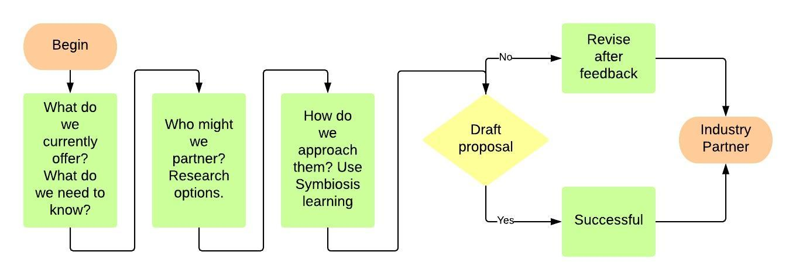
In-project evaluation
Consistency matters! Use the same tools as at the beginning. Be honest and ask:
- What have we/I learnt (quantify and describe it, even briefly. Describe `soft’ skills as well as hard knowledge; describe unexpected events, impacts, partners, changes of direction and learning)
- Where next?
Again, this can be done as a group or individual exercise or both.
Summative (end of project evaluation)
Revisit your baseline. How far have you come? Hold a group or team discussion. Fill in individual logs or revisit your flow chart.
Distance travelled tape. You can use visual tools such as a ribbon or tape stretched around the room or across one wall, representing `distance travelled’. Mark points which show progression from `No knowledge’ or ` No confidence’ to `lots of knowledge’ ` Lots of confidence’.
Ask people to place themselves at a point on the tape which describes how much they have learned and how far they have travelled. Take a photo.
Personal object. As part of a group discussion ask people to bring in an object of any kind which symbolises their learning and explain the accompanying story.
Review hard and quantitative data – how many approaches to industry partners? How many other projects as a result of the knowledge exchange? How are these reflected in Forward plans, activity logs, policy documents?
Triangulate your data – get feedback from your industry partners both successful and unsuccessful.
Reflect, Revise, Repeat!

