Image request form
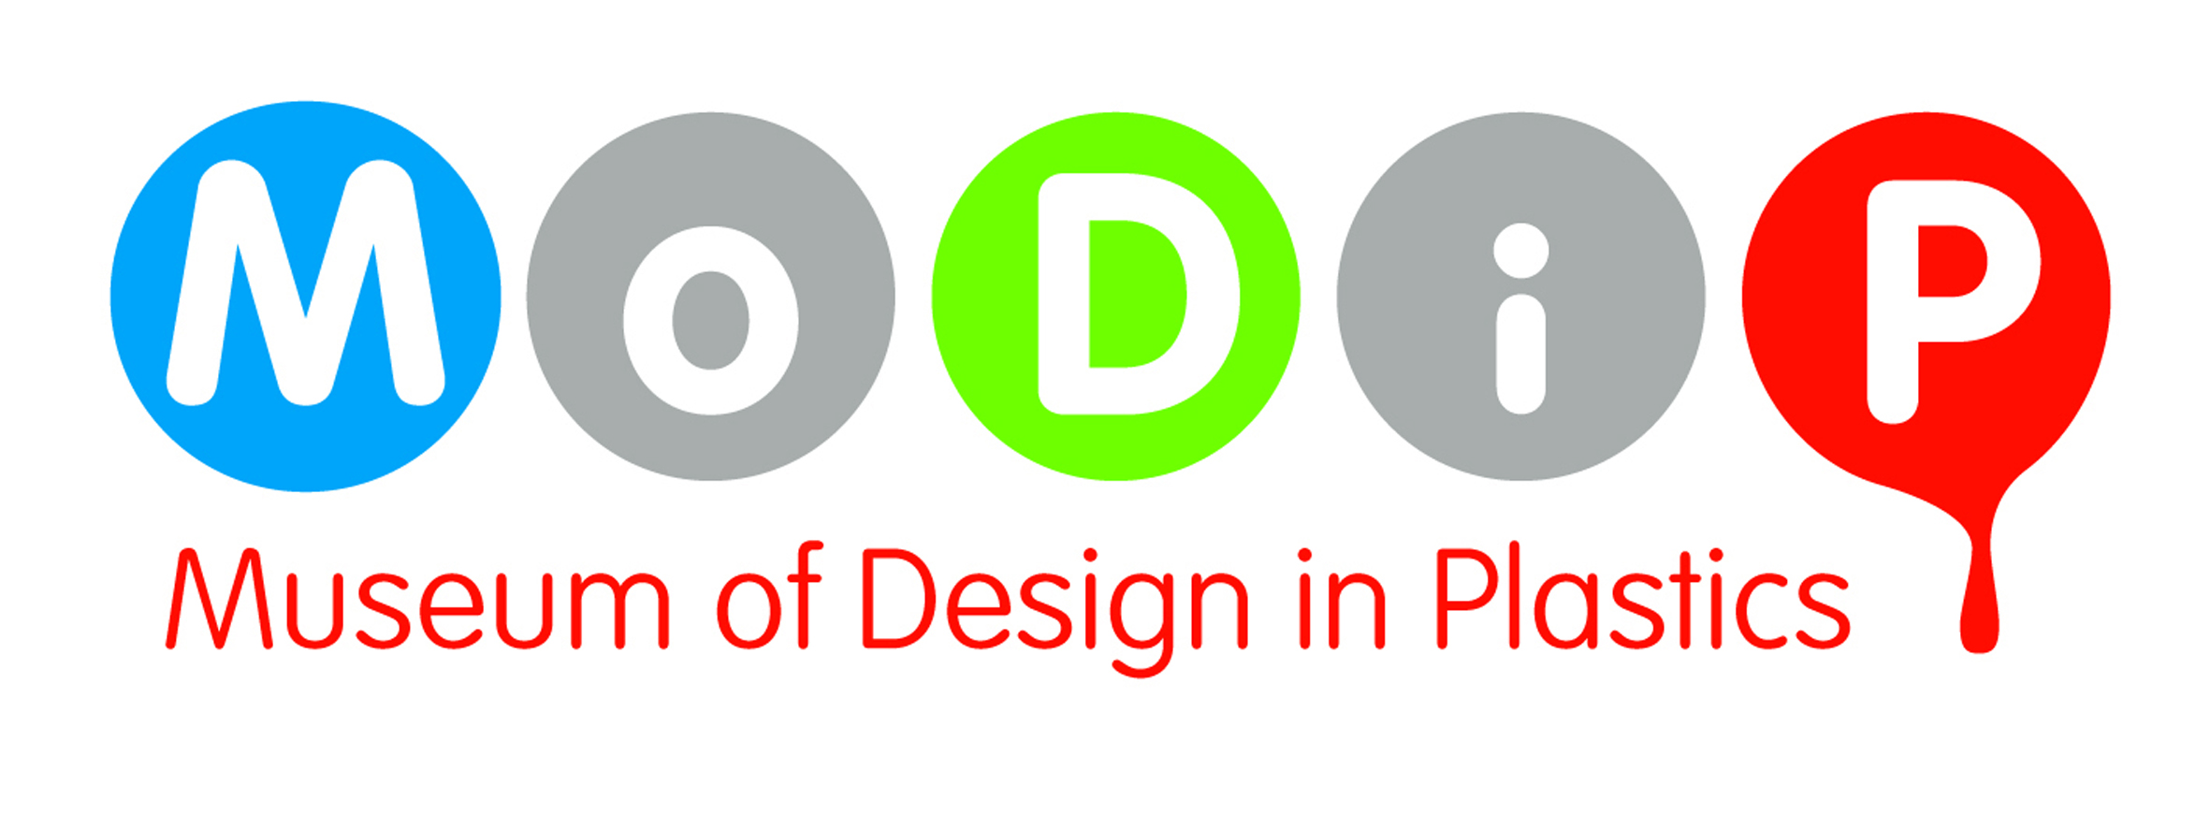

Your Details:
Name
Company name
Address
Tel No
Email

Image/s requested:
Description / Title | Accession Number | Which view of the object

Usage Details:
Title of publication and / or article
Author and / or editor
Publisher
Date (When do you want the image/s – as much notice as possible required)
Image size required (in px or cm)
Images will be supplied digitally to the above email address – by a transfer service eg. We Transfer if necessary.

MoDiP has IPR permission to use images on its website. For images requested beyond this use, it is the responsibility of the requester to gain permission from the manufacturers and/ or designers responsible for the production of the object illustrated. MoDiP will supply images on the understanding that the requester will seek the additional permissions.

Recompense: As recompense for supplying the image/s MoDiP would like a copy of the publication in which they are featured.

Credit line: Images should be accompanied by the following credit line - Museum of Design in Plastics, Arts University Bournemouth.

Declaration: I understand that MoDiP is supplying this/ these image/s on the basis that I take responsibility for acquiring any additional permission from the manufacturers and / or designers of the objects in the images I have requested.

Signed: ……………………………… Dated: …………………………………………

Please email this form to modip@aub.ac.uk or post to MoDiP, Arts University Bournemouth, Wallisdown, BH12 5HH

